**TITLE: - AUTOMATIC FISH FEEDER**

**ABSTRACT**

The "Aqua Care Automatic Fish Feeder" is a device designed to automate the feeding of aquarium fish. Featuring a user-friendly interface, the feeder includes a straightforward on/off switch and a power connector for electrical operation. Its decorative design, adorned with fish and floral patterns, enhances its aesthetic appeal, making it a visually pleasing addition to any aquarium setup. Packaged with clear labeling and vibrant branding, the Aqua Care Automatic Fish Feeder aims to provide convenience and ease of use for aquarium enthusiasts, ensuring consistent feeding schedules for fish without manual intervention.

Top of Form

Ms K.Shanmukha Priya Dr.v. karthick

**TITLE: - AUTOMATIC FISH FEEDER**

**PREAMBLE TO THE DESCRIPTION**

**THE FIELD OF INVENTION**

Focuses on improving fish feeding practices in controlled environments such as aquariums, ponds, and commercial fish farms.

Introduces automation to reduce manual labor and ensure consistent feeding routines.

Ensures accurate portion control and feeding schedules, promoting optimal fish health and growth.

Potential integration with smart devices and sensors for real-time monitoring and remote control of feeding operations.Potential integration with smart devices and sensors for real-time monitoring and remote control of feeding operations.

Contributes to sustainable fish farming by minimizing waste and optimizing resource use through automated feeding systems.

**BACKGROUND OF THE INVENTION**

Introducing the Aqua Care Automatic Fish Feeder, the perfect solution for ensuring your fish are well-fed and healthy, even when you're not around. Our automatic feeder is designed with convenience and efficiency in mind, making it an essential addition to any aquarium setup.

**SUMMARY OF THE INVENTION**

The Automatic Fish Feeder is designed to automate the process of feeding fish in various aquatic environments, such as home aquariums, ponds, and commercial fish farms. The device ensures that fish receive consistent, accurate portions of food at scheduled intervals, thereby reducing the need for human intervention. This feeder may be equipped with adjustable settings for portion size and feeding frequency, catering to different species and environments.

Ms K.Shanmukha Priya Dr.v. karthick

**TITLE: - AUTOMATIC FISH FEEDER**

**COMPLETE SPECIFICATION**

**Specifications**

The Automatic Fish Feeder is designed with a compact and durable build, typically made from food-grade plastic or stainless steel to ensure safety and longevity in aquatic environments. It features a versatile mounting system, including suction cups, clamps, or brackets, allowing it to be securely attached to various tank or pond setups. The device is equipped with an adjustable food compartment that can accommodate different types of fish feed, such as pellets or flakes. It offers programmable settings for portion size and feeding frequency, enabling precise control over the feeding schedule. Additionally, the feeder may include a moisture-resistant design to prevent food from clumping or spoiling, ensuring that fish receive fresh feed every time. For added convenience, some models may feature a digital display or IoT connectivity, allowing remote monitoring and control via a smartphone or other smart devices.

Ms K.Shanmukha Priya  Dr.v. karthick

**TITLE: - AUTOMATIC FISH FEEDER**

**DESCRIPTION**

The **Automatic Fish Feeder** is an innovative device designed to automate the feeding process for fish in aquariums, ponds, and aquaculture setups. It consists of a compact, robust housing made from food-grade plastic or stainless steel, ensuring durability and safety in aquatic environments. The feeder is equipped with an adjustable food compartment, capable of holding various types of fish food, including pellets, flakes, or granules.

**Figure.1.AUTOMATIC FISH FEEDER**

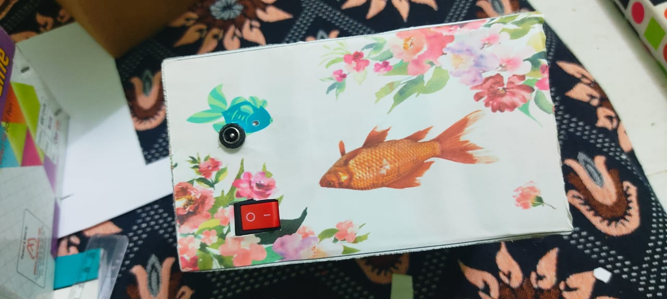

Mr K.Shanmukha Priya Dr.v. karthick

**TITLE: - AUTOMATIC FISH FEEDER**

CLAIM

**We Claim**

**Claim: Hierarchical Feeding Control**  
Our Automatic Fish Feeder implements a multi-level feeding control system, allowing Administrators, Aquarists, and Technicians to simultaneously manage the feeder while restricting functionalities based on user roles. This enhances security and efficiency by ensuring that each user can only access features relevant to their role within the feeding system.

**Claim: Automated Feeding Schedules**  
Simplifies fish care by automating feeding schedules for different species or tanks. This reduces the aquarist's workload and ensures timely and consistent feeding, enhancing the overall efficiency and health of the fish.

**Claim: Feeding Performance Analytics**  
Utilizes data analytics tools to analyze feeding performance and usage trends within the Automatic Fish Feeder. By leveraging historical data and predictive analytics, administrators and aquarists can identify feeding patterns, optimize schedules, and ensure the feeder operates at peak efficiency.

**Claim: Feedback-driven Enhancements**  
Facilitates continuous improvement of the Automatic Fish Feeder by providing users with a feedback mechanism within the device's app. This empowers administrators and aquarists to gather insights, address concerns, and make enhancements based on user feedback, ultimately improving the quality of the feeder and the health of the fish.

.

Mr K.Shanmukha Priya Dr.v. karthick